**Project documentation**

**Emergency call button**

Date: **14/02-11**

Advisor: Kim Bjerge

Project participants: Jørgen Vrou Hansen (20042728)

Saiid Shah Alizadeh (19963592)

Anders Hvidgaard Poder (19951439)

Revision: **A**

Document ID: **PRODDOC**

# Introduction

This document details the process, decisions and result of the Emergency button project. A prerequisite for reading this document is to have read the project proposal and the one-page intro.

The document begins by describing the process and then continues to describe the individual parts of the project as it progresses through the process. Naturally the process is iterative in nature, yet in the document any changes will be described under the section they relate to, and the document may therefore not be seen as a chronological detail of the process. Where changes occurs the point of origin will naturally be described along with its affect to earlier section in the change log.

# Process

1. Analyse project proposal and create SRD
   1. Domain model
   2. System level requirements
      1. Use cases.
      2. Sequence diagrams where needed.
      3. Non-functional requirements.
2. Refine SRD to SRS
   1. State and activity diagrams to clarify use cases.
   2. Detailed requirements from system requirements – Should we do this?
   3. Requirement traceability from system to detailed requirements.
   4. Traceability for changed requirements.
3. Overall architectural design
   1. Identify blocks and create overall structure
   2. Mapping of blocks to requirements, both in diagram and RVTM (V is not part of report)
   3. Create internal block diagram for important blocks.
   4. Create activity, state, sequence and other diagrams where needed.
   5. Modify requirements if needed.

3a. SySMl for SoC and design and SystemC transformation

* 1. Relate SySML block to SystemC module
  2. SystemC notation on SysMl diagrams
  3. Partitioning SysML blocks into 1 or more SystemC modules.
  4. Describe the process, important considerations

1. SystemC TLM of overall architectural design
   1. Map functional blocks to SystemC module.
   2. Create communication channels (mostly standard FIFO).
   3. Modify architecture/requirements if needed.
2. Architecture mapping
   1. Identify alternative architectures.
   2. Create architectural design for each alternative.
3. Process mapping for each alternative architecture
   1. Identify processes.
   2. Identify communication.
   3. Map Processes to PE and Communication channels to CE
4. SystemC Timed TLM for each alternative architectures
   1. Update and refine SystemC to the alternative architecture
   2. Identify delayes in the proceses and communication channel based on rough estimation.
   3. Implement delays in SystemC.
   4. Simulate the system and compare the results.
5. Conclusion
   1. Evaluate the pros and cons of the alternative architectures.
   2. Evaluate the process.

# Domain model



Figure 1 - Domain model drawing

In Figure 1 may be seen the overall parts of the Emergency call system including their communication paths. Only a small part of the above is part of this project, yet it is important to realize the domain in which the project operates.

The system functions as follows:

1. An emergency call base is installed in the home of the person receiving care and an emergency call button is issued to that person.
2. The Emergency button communicates with the emergency call base using the ISM network.
3. The emergency call base communicates with the phone company server using its built-in GSM modem and SIM card via a Base Tranceiver Station (BTS).
4. The phone company server forwards the communication via the internet to/from the emergency call server (naturally in a properly protected tunnel).
5. The emergency call server forwards the communication to/from the interested parties; technician, care giver or both.

The above may be formalized in a SysML Domain Basic Block Diagram as shown in Figure 2.



Figure 2 - Emergency call system Domain

In Figure 2 may be seen not only the System Of Interest, but also the environment in which it operates and the blocks with which it interconnects.

The environment in which the emergency call button operates is one where it may be operated by an elderly or disabled person, and may therefore be exposed to some degree of moisture and shocks, as well as worn continuously for a long time.

The ISM network naturally suffers from limited range, noise and interference, which is all part of the ISM network.

The Emergency call base is the communication gateway between the Emergency call server and the Emergency call button. It also has other responsibilities, yet they are irrelevant for this project. The communication goes via the GSM network, which also suffers from limited range, noise and interference as well as a third party service provider (the phone company). In the target area it is believed that with a sufficiently large and well placed GSM antenna a sufficient signal may always be achieved (assumption). Furthermore the GSM network has been thoroughly tested and the service providers have strong incentives to keep a very high availability.

The Emergency call server is placed in a protected environment with sufficient power and network access, and can reach the technician and caregiver on duty using either the head-office LAN , SMS Gateways and/or other third party services.

Focussing on the System-Of-Interest a set of requirements may be created from the project proposal. As the focus on this project is proof-of-concept some of the detail requirements (e.g. colour, frame IP rating, …) will be excluded just like only the critical requirements, especially those containing implemtational risks, will be broken down in the architecture.

# Requirements

This section contains both the overall system requirements (SRD) and the refined requirements (SRS) in one, as the project is an in-house project with close proximity to the “customer”. It therefore does not make sense to create two separate documents, but is far more efficient to simply create the SRS right away.

Again the requirements are only the system requirements and do not include all detailed requirements, yet should contain sufficient data to complete a proof-of-concept.

Before we dive into the creation of the requirements we should look at the Quality attributes of importance to this system, as well as the challenges in meeting these requirements.

## Quality attributes

There are several schools of system architecture, many of which define their own set of quality attributes. A well known and recognized set is the one defined by [BASS] as follow:

* Availability
* Modifiability
* Performance
* Security
* Testability
* Usability

Many add an extra quality attribute:

* Safety

And finally there are some business oriented attributes:

* Time to market
* Cost

Naturally all of these are important, but some are more important than others, and some are also more likely to cause trouble. It is therefore important to include a risk assessment in the quality attribute analysis.

Naturally Safety is vitally important, but at the same time as this product focuses almost entirely on communication, most of the safety aspect is contained in Availability, and the only true Safety aspect is pinching ones finger in the button, scratching oneself on the frame or the battery blowing up. Looking at cell phone manufacturers the last safety aspect is actually a real one, especially as the emergency call button might get damp and warn close to the skin. We do however believe that the current EU regulations cover these aspects, and that sufficient experience exists to avoid this problem, and the risk of violating requirements for the safety attribute is low.

Second come Availability. The button must “always” be able to report an emergency (including battery low situations). Naturally there is no such thing as “always”, so an acceptable probability of failure must be agreed to. In the present system there is no fault detection, but the “buttons” are made so simple that a very high Mean-Time-Between-Failure (MTBF) can be achieved. In this must also be included the probability of a failure later in the communication path, but as these units are on a continuous power supply they can maintain a much higher fault detection frequency. It is believed that the probability of mechanical failure (the button gets stuck or the micro switch fails) can be considered negligible, making the state of the microcontroller a sufficiently deep fault detection.

Usability is also vitally important. Here the experience from existing system may be used to determine the optimal size, colour, location and feel of the button itself. Charging the emergency call button is a much more interesting aspect, as the existing “buttons” very rarely needs to have their battery replaced.

Testability is interesting in the sense that it is important to verify especially the Availability requirements, so it should be considered when writing the test cases and also when implementing the product.

Naturally a certain level of Performance is required, but the response times that is expected lies well below the technical capabilities of the technology available, and the risks here are therefore minor.

Modifiability is more of a nice to have as the cost of the individual emergency call button is such that the entire button may simply be replaced in lieu of updating the firmware, and also gaining access to the buttons themselves are relatively simple, as central lists of their whereabouts are kept at the municipalities.

Finally there is Security, and for this project it is not important. No confidential information should be exchanged on this medium and the desire for someone to want to impersonate an emergency call button is most likely quite small. Naturally the emergency call buttons must be distinguishable from each other, but protection against someone intentionally trying to spoof an emergency call button is not required.

From the above it is possible to create a prioritised list of quality attributes along with their estimated level of complexity (and thereby risk).

|  |  |  |  |
| --- | --- | --- | --- |
| Priority | Quality attribute | Complexity (0 – 10, where 10 is highest complexity, i.e. highest risk) | Flexibility (0 – 10, where 10 is highest flexibility) |
| 1 | Safety | 1 | 0 |
| 2 | Availability | 8 | 3 |
| 3 | Usability | 3 | 2 |
| 4 | Testability | 4 | 8 |
| 5 | Performance | 4 | 5 |

The reason it is important to include the complexity of achieving the required level and the allowed flexibility, is so it is possible to know where there may be some leeway. If the flexibility is 0 it is not even worth looking at, as there are (most likely) strong legislative reasons why this quality attribute must be met to the exact specification. Naturally the complexity and flexibility is a rough estimate based on the developers and architects understanding of the task at hand, and may change as the project progresses, yet if there is a high degree of uncertainty it might be a good idea to reduce this uncertainty before progressing, or at least address this module first in the further development.

When these priorities are in place it is possible to address the business side of the quality attributes. Many newer schools of development argue that you cannot (or at least should not) change the quality, only adjust the number of features included to meet the time and cost schedule. This is often illustrated by the triangle shown in Figure 3, often called the iron triangle because it is possible (ideally) to control two sides of the triangle, but never three. So if you are willing to pay anything, you can have all the features in a very short amount of time, but if you are not willing to pay very much, and you want it yesterday, then you cannot have very many features.

The problem with this triangle is that it does not take non-functional requirements into account, like many of the quality attributes are. The reason this is important is that it may also be possible to save significant money and time if the client is willing to lower the availability requirement, without touching the functional requirements (the features). This is where the complexity comes into play, as it shows how much there might be potentially gained in time and money by adjusting these parameters. This should then be combined with the flexibility, to gain an impression not only on how much is there to be gained, but also how willing (able) is the client to make changes to these requirements.

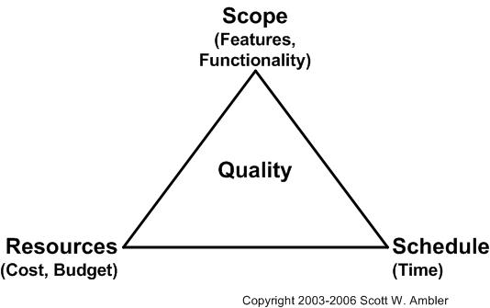

Figure 3 - Iron triangle

## Rationale

Diving into the actual requirements we can derive a lot of the information directly from the project proposal, current legislation, existing solutions, and some from the specification of the emergency call base. Other requirements, like the maximum allowed time between failure detection, are derived from a combination of risk assessment and acceptable delays as indicated by the caregivers. By estimating a mean time between failures (MTBF) and an acceptable response delay and failure probability it is possible to calculate the required fault detection interval in order to meet the indicated fault probability figure.

This calculation can be done as follow:

* MTBF = 365 days.
* Acceptable extra delay = 30 minutes (a total response time of 60 minutes).
* Acceptable probability that the +30 minutes requirement is not met = 0.1%.

The probability that the error occurs in the time more than 30 minutes from a fault detection is (X – 30) / (365 * 24* 60) => (X – 30) / 525600, where X is the interval between fault detection. Combining this with the required probability gives (X – 30) / 525600 = 0.001 => X – 30 = 525.6 => X = 555.6 minutes, or a fault detection every 9 hours, and the2 hours is therefore acceptable.

Naturally the probability that one unit in a collection of units do not meet the above specifications is different (relative to the size of the collection).

## Content

Please refer to [REQSPEC] for the actual requirements.

TODO: Should we insert the requirements here, or refer to the document?

# Architecture

The architecture of the system can be separated into two parts

1. General architecture
2. Mapping specific architecture

The general architecture is characterised by being independent on mapping to HW and SW, where the mapping specific architecture is dependent on selecting the platform on which the general architecture must exist. The Mapping specific architecture is a refinement of the general architecture, and must therefore not be in conflict with the general architecture.

## General architecture

In order to define the general architecture the individual blocks that make up the system of interest must be defined. This is done using a Block Definition Diagram, as may be seen in Figure 3.



Figure 4 - General Architecture Block Definition Diagram

TODO: Is it OK to have blocks that are not owned by anyone???

TODO: What about firmware update?

The creation of Figure 3 comes from analyzing the requirements and grouping the required functionality. It may furthermore be seen that no decision has been made as to what is realized in HW or SW, with the exception of the Housing, which must, for obvious reasons, be realized in HW.

When transforming the requirements into an overall architecture many different techniques may be used. An example is [SOFTARC], and though these books focus on Software Architecture, they may also be for HW/SW architecture. Though many books on architecture exist, a certain level of experience is extremely valuable when choosing the correct architecture.

Looking at the Quality Attributes we can see that it is a relatively static system; no Plug-and-play, no on-the-fly core updates, no third party peripherals. This means that the architecture does not need to include pluggable components or extendable drivers.

The high requirements for availability points to a simple system; the number of errors in a system is always proportional to the amount of code, and also a system that can be tested thoroughly, which requires interfaces for testing the modules independently.

There are many different architectures that can fulfil the requirements, and there may even be several equally good architectures. Therefore choosing an architecture becomes a matter of weighing the quality attributes against the architectural patterns that are suited to satisfy them and combine this with experience. Naturally the architectural patterns should be modified as needed to only include the parts of the patterns that are necessary for this application.

Grouping the requirement into independent blocks using the techniques described above, a possible collection of architecture blocks could be the one shown in Figure 3.

Here is may be seen that the following blocks and their responsibilities has been identified:

* Housing
  + The physical frame that holds the electronics. This is per definition HW, and it has no intelligence or electrical components, only housing.
* Antenna
  + The physical antenna used by the ISM block, as well as potentially any required physical components not part of the ISM block.
* ISM
  + The logic required to package and transmit a data stream / data frame to the Antenna and receive a data stream / data frame from the Antenna. The block is also responsible for maintaining the connection, if there is a connection to maintain (depends on the low-level protocol), required channel hopping, etc. The exact division of responsibility between the Antenna and the ISM block with respect to physical components may be adjusted depending on the mapping.
* LED
  + The physical LED as well as any required low-level driver and physical components required by the LED (often a discrete output is dimensioned so it can drive an LED directly).
* Button
  + The physical button as well as any required low-level driver and physical components required by the button (e.g. a simple hysteresis circuit to prevent multiple activations).
* Battery
  + The physical battery, the charging circuitry and monitoring circuitry as well as any required low-level driver.
* Microphone
  + The physical microphone as well as any required low-level driver and physical components required by the microphone (e.g. an external filtration or amplification circuit).
* Speaker
  + The physical speaker as well as any required low-level driver and physical components required by the speaker (e.g. an external filtration or amplification circuit).
* Control
  + The control logic which maintains the overall state of the system, including timing (when to check battery status, when to send heartbeats), commands from the base (cancel emergency, update firmware) and peripherals (button, LED). The Control logic also is responsible for turning on and off the Audio.
* Communication
  + The communication logic which handles the application level data to and from the ISM block. It is responsible for adding the any required frame header and/or footer specific to the application and to distribute received data to Control or Audio depending on the content (received frame header/footer).
* Signal Strength control
  + The logic responsible for adjusting the transmission strength of the ISM module based on e.g. number of retransmissions (BER), received transmission strength or information from the based.
* Audio
  + The logic responsible for; sampling the microphone, filter out the feedback noise and package the data and send it to the Communication block, receiving audio frames from the communication block, unpack the data and send it to the speaker and the feedback filter. The Audio block may be enabled and disabled depending on whether an emergency is ongoing.

### Dependencies and flow

The above Basic Block Diagram (BBD) only shows the blocks that make up the system and some information about what blocks are part of other blocks, but it does not show how blocks communicate. For that we need the Internal Block Diagram (IBD).

Here we will focus on the important blocks, meaning the blocks that have some data flow, and the blocks that have an interesting interface.

The remaining blocks should naturally also be done, but they are not imperative to do a proof-of-concept or to choose an architecture and platform.

#### Control

The main state machine, as shown in the requirements specification, is implemented in the Control block, and it is therefore interesting to see which interfaces this block exposes and need. This may be seen in Figure 5.

Here it may also be seen that the all interfaces are standard interfaces, there are no flow data. This is an architectural decision to keep the flow data and the control data separate.



Figure - Control Internal Block Diagram

In Figure 5 the following sub-blocks has been defined with their own responsibilities:

* Command Handler
  + Handle all commands, whether from the communication channel, the button or a timeout of the RTC (heartbeat).
* Communication Handler
  + Handle all communication to and from the Communication block. This block is responsible for parsing the command messages and parsing on the correct command, as well as packaging any responses for transmission.
* Test battery status and perform heartbeat
  + This is the only timer that must be active at all times. It is responsible for waking the system at predefined intervals to send a heartbeat and/or test the battery.

#### Audio



Premature specification with the ADC / DAC – they could be part of the microphone /speaker, e.g. an active speaker.

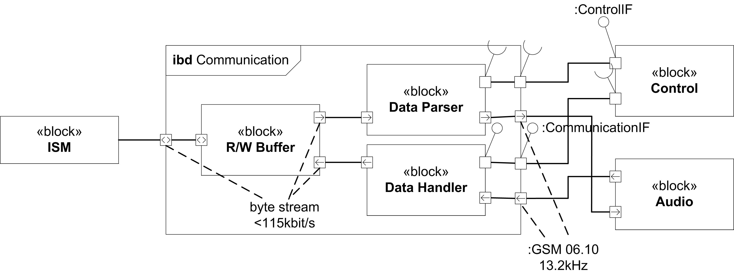



***In the heartbeat it is possible to report status information, e.g. battery level.

References:

* Pattern-Oriented Software Architecture